

MilkoScanTM Mars

The MilkoScan for everyone
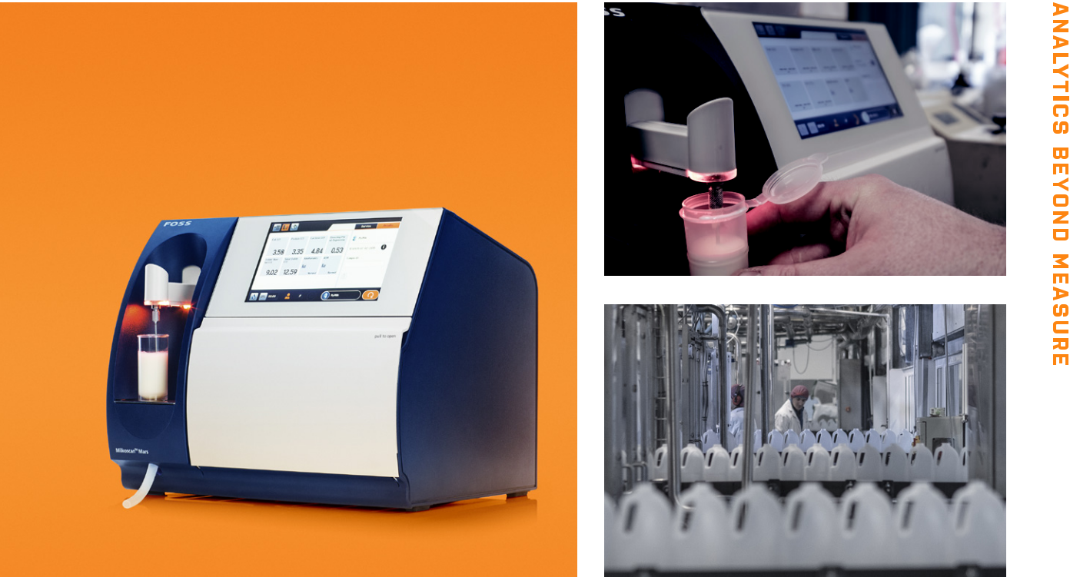

MilkoScanTM Mars puts powerful FTIR analytical technology within the reach of small to mid-size dairies, helping them to avoid slow and la-bour-intensive traditional testing methods and improving their ability to spot deliberate or accidental adulteration of the milk supply.

Easy to run and cost-effective

MilkoScan Mars is supplied with ready-to-use calibrations allowing you to control and standardise milk or cream products for optimal use of raw material and consistent quality products. Plug it in and you are ready to start testing immediately.

The simple way to analyse milk and get instant quality control Simply place the sample under the pipette and press start to get anal-ysis results of up to six parameters in just one minute. Keep cost down with robust flow system and no need for chemicals or disposables.

Unique ability to screen for adulterants with FTIR technology Check milk for known adulterants and anything that looks abnormal at the same time as performing other quality checks. MilkoScan Mars allows you to start screening from day one with ready-to-use screen-ing models.

Sample type

Milk, cream and whey

Parameters

Global calibrations: Fat, protein, lactose, total solids, solids non-fat, freezing point (milk only)

Targeted and untargeted adulteration screen-ing

Technology

FTIR technology for milk analysis - used by more than 5.000 major dairy users worldwide

Specifications

Feature

Dimensions (w x h x d)

Weight

Power supply

Power consumption

Ambient temperature

Ambient humidity

Environment

Noise level

Measuring range

Accuracy

Repeatability

Analysis time

Sample volume

Sample temperature

Cleaning

Calibration routine

Network connection

*Coefficient of variation

Specification
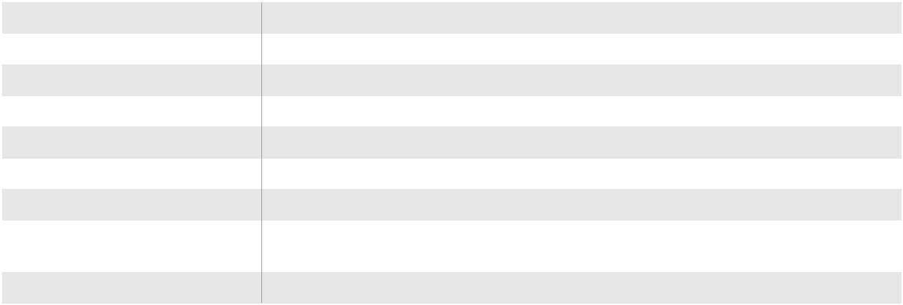

345 x 285 x 280 mm

10.5 kg

(100 to 240V) V - 50/60 Hz

12V, 5A, - 60 W

5-35°C

<80RH

For best performance place the instrument on a stable surface away from excessive and continuous vibration

< 70 db (A)

0-48 % fat | 0-12 % SNF
0-6 % protein | 0-12 % SNF
0-6 % protein | 0-6 % lactose
0-50 % total solids | 0-6 % lactose
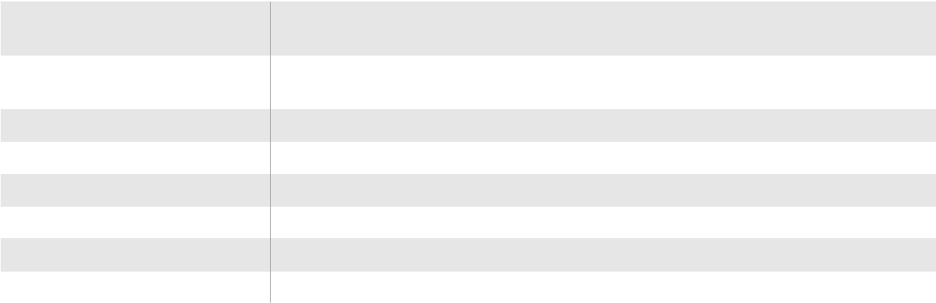

- 1.2 % CV* on major raw cow’s milk components (fat, protein, lactose, total solids, solids non fat)

- 0.5 % CV* on major raw cow’s milk components (fat, protein, lactose, total solids, solids non fat)

1 min. for milk

6 ml.

5 – 40 °C (the sample must be homogeneous)

Automatic and programmable

Slope / Intercept adjustment

FossManagerTM


Included calibrations
Milk | Fat, protein, lactose, total solids, solids non fat, freezing point
Cream | Fat, protein, lactose, total solids, solids non fat
Whey | Fat, protein, lactose, total solids, solid non fat
Untargeted model for adultera- | Ready to use model for screening for abnormal raw cow’s milk
tion screening | Ready to use model for screening for abnormal raw cow’s milk
Targeted models | Ready to use screening models for urea, sucrose, formaldehyde, sodium bicarbo-
for adulteration | nate, potassium nitrate in cow’s milk

MilkoScan™ Mars is CE labelled and in compliance with AOAC (Association of Analytical Chemists) and IDF (International Dairy Federation).

Sole distributor in Romania and Moldavia:
SERVITECH EXPRES S.R.L.
Phone: +40 744 433 283
Email: contact@servitechexpres.ro
Web: www.servitechexpres.ro
RO, December 2020

Source: www.fossanalytics.com

